**Phase 1 report (OS Project)**

**Project guide**

**Instructor: Dr. Mona Farouk**

**Tas:**

**Eng.Hanan Khaled Shaaban**

**Eng. Amira Elkammar**

**Presented by:**

**Salahdin Ahmed 202201079**

**Abdelhady Mohamed 202201172**

**Shehab Mohamed 202200285**

**Ahmed Almuhanna 202202017**

**Data structure used:**

|  |  |
| --- | --- |
| **Algorithm** | **DS** |
| SJF | Priority Queue |
| PHPF | Priority Queue |
| Round Robin | Priority Queue |

**Algorithm explanation and results:**

* **Algorithm Explanation**

1. Receive and push all processes came in the current second
2. Check the running process if it finishes or not (Check its remaining time through the according shared memory)
3. Check if the ready queue is not empty:

**.** True: based on the algo, we decide that we will switch or not

1. Wait till the next second

* **Results:**

1. **SJF:**

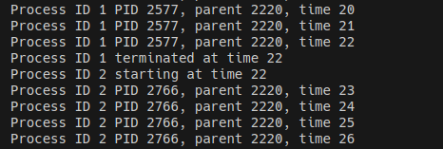

1. **PHPF:**

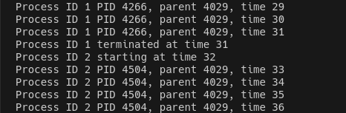

1. **RR:**

**Assumptions:**

**Workload distribution:**

|  |  |
| --- | --- |
| **Salahdin Ahmed** |  |
| **Abdelhady Mohamed** |  |
| **Shehab Mohamed** |  |
| **Ahmed Almuhanna** |  |

**Time taken:**

|  |  |
| --- | --- |
| **Method** | **Time** |
| **Algorithms** |  |
| **Shared Memory** |  |
| **DS** |  |
| **Output file** |  |